  - NATIONAL INTEGRITY FRAMEWORK

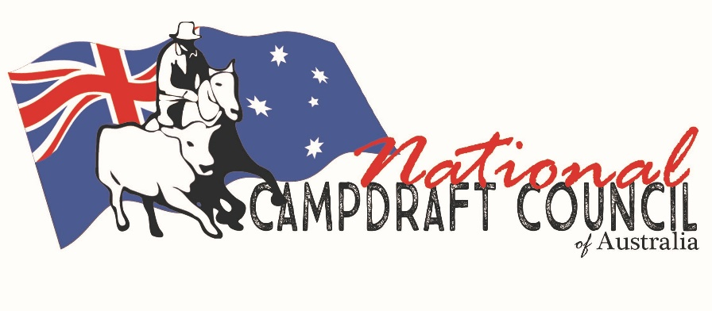

National Campdrafting Council of Australia Member Protection Policy

Commencement date endorsed: 1ST July, 2022

Policy to be reviewed by Sport Integrity Australia September - December 2022

TABLE OF CONTENTS
1. Definitions 1
2. Jurisdiction 1
2.1 Who the Policy applies to 1
2.2 When the Policy applies 2
3. Prohibited Conduct 2
3.1 Prohibited Conduct 2
4. Complaints, Disputes & Discipline Policy 3
5. National Integrity Framework 3
SCHEDULE 1 - Examples of Prohibited Conduct 4

SUMMARY
National Campdrafting Council of Australia is committed to ensuring that everyone involved with Campdrafting is treated with respect and dignity and is protected from abuse, bullying, harassment, sexual misconduct, unlawful discrimination, victimisation, and vilification.
This Policy seeks to ensure that everyone involved in our Campdrafting is aware of their rights and responsibilities. This Policy sets out the standards of behaviour expected of those involved in our Campdrafting and the behaviours that are not acceptable (‘Prohibited Conduct’).

Definitions and interpretation

Defined terms
Defined terms not otherwise defined in this Policy have been defined in, and have the meaning given to them in the National Integrity Framework. In this Policy, the following words have the corresponding meaning:
Abuse means any type of abuse (including physical, emotional, psychological, sexual, and inappropriate use of power) that has caused, is causing or is likely to cause harm to a person's wellbeing, whether in person or as the result of a publication viewable by any other person by any means.
Bullying means a person or group of people repeatedly and intentionally using words or actions, or the inappropriate use of power, against someone or a group of people to cause distress and risk to their wellbeing.
Harassment means any type of behaviour towards a person that they do not want and that is offensive, abusive, belittling or threatening and is reasonably likely to cause harm to the person who is the subject of the harassment.
Policy means this Member Protection Policy including any schedules and annexures.
Prohibited Conduct means the conduct proscribed at clause 3 of this Policy.
Sexual Misconduct means:

Sexual Harassment, which is any unwanted or unwelcome sexual behaviour where a reasonable person would anticipate the possibility that the person being harassed would feel offended, humiliated, or intimidated; and

Sexual Offences, which include any criminal offence involving sexual activity or actions of indecency.
Unlawful Discrimination includes:

Direct Discrimination, when a person or group of people is treated less favourably than another person or group, because of a personal characteristic; and

Indirect Discrimination, when an unreasonable rule or policy applies to everyone but has the effect of disadvantaging some people because of a personal characteristic they share, where such personal characteristic is protected by applicable anti-discrimination legislation.
Victimisation means subjecting a person, or threatening to subject a person, to any unfair treatment because the person has made, or intends to pursue their right to make, a complaint or lawful disclosure, including under applicable legislation or this Policy, or for supporting another person to take such action.
Vilification means a public act, conduct or behaviour that incites hatred, serious contempt for, or revulsion or severe ridicule of, a person or group of people because of a particular characteristic they hold, as covered by applicable legislation, including their race or religion, or homosexuality, transgender, or HIV/AIDS status.

Interpretation
Definitions of Abuse, Bullying, Harassment, Sexual Misconduct, Unlawful Discrimination, Victimisation and Vilification must be read in the context of SCHEDULE 1.

Jurisdiction

Who the Policy applies to?
This Policy applies to:

Relevant Persons; and

Relevant Organisations.

When the Policy applies

All Relevant Persons and Relevant Organisations to which this Policy applies must always comply with this Policy (whilst they are a Relevant Person or Relevant Organisation), including:

in relation to any dealings, they have with Relevant Organisations or their staff, contractors, and representatives;

when dealing with other Relevant Persons or Relevant Organisations in their capacity as a Relevant Person/Relevant Organisation; and

in relation to their Membership or standing as a Relevant Person or Relevant Organisation in general.

The following is not within the scope of this Policy:

where an interaction (including social media interactions) occurs involving one or more Relevant Persons or Relevant Organisations, and the only link or connection between the interaction and the Campdrafting is the fact that one or more individuals are Relevant Persons or Relevant Organisations; and

where Prohibited Conduct occurs in contravention of this Policy, any subsequent conduct, or interaction(s) that, whilst related to the original Prohibited Conduct, no longer directly relates to any of the Campdrafting (even where such conduct or interaction(s) would otherwise be Prohibited Conduct).

Prohibited Conduct

Prohibited Conduct
A Relevant Person or Relevant Organisation commits a breach this Policy when they, either alone or in conjunction with another or others, engage in any of the following conduct against one or more Relevant Persons or Relevant Organisations, in the circumstances outlined in clause 2:

Abuse;

Bullying;

Harassment;

Sexual Misconduct;

Unlawful Discrimination;

Victimisation; or

Vilification.
SCHEDULE 1 sets out examples of what may constitute Prohibited Conduct under this Policy.

Complaints, Disputes & Discipline Policy

The Complaints, Disputes and Discipline Policy applies to any alleged Prohibited Conduct, including reports of breaches, of this Policy.

National Integrity Framework
The National Integrity Framework applies to this Member Protection Policy. When interpreting this Policy, any provisions inconsistent with the National Integrity Framework apply to the extent of that inconsistency.
- - Examples of Prohibited Conduct
- Abuse must be behaviour of a nature and level of seriousness which includes, but is not limited to:
- physical abuse and assault including hitting, slapping, punching, kicking, destroying property, sleep, and food deprivation, forced feeding, unreasonable physical restraint, spitting at another person or biting;
- sexual abuse including rape and assault, using sexually degrading insults, forced sex or sexual acts, deliberately causing pain during sex, unwanted touching or exposure to pornography, sexual jokes, using sex to coerce compliance;
- emotional abuse such as repeated and intentional embarrassment in public, preventing or excluding someone from participating in sport activities, stalking, humiliation, or intimidation;
- verbal abuse such as repeated or severe insults, name calling, criticism, swearing and humiliation, attacks on someone's intelligence, body shaming, or aggressive yelling;
- financial abuse such as restricting access to bank accounts, taking control of finances and money, forbidding someone from working, taking someone's pay and not allowing them to access it;
- neglect of a person's needs.

- Bullying must be behaviour of a nature and level of seriousness which includes, but is not limited to, repeatedly:
- keeping someone out of a group (online or offline);
- acting in an unpleasant way near or towards someone;
- giving nasty looks, making rude gestures, calling names, being rude and impolite, constantly negative and teasing;
- spreading rumours or lies, or misrepresenting someone (i.e., using their social media account to post messages as if it were them);
- 'fooling around', 'messing about' or other random or supposedly playful conduct that goes too far;
- harassing someone based on their race, sex, religion, gender, or a disability;
- intentionally and repeatedly hurting someone physically;
- intentionally stalking someone; and
- taking advantage of any power over someone else,
but does not include legitimate and reasonable:
    - management action;
    - management processes;
    - disciplinary action; or
    - allocation of activities in compliance with agreed systems.

- Harassment must be behaviour of a nature and level of seriousness which includes, but is not limited to:
- telling insulting jokes about racial groups;
- sending explicit or sexually suggestive emails or text messages;
- displaying racially offensive or pornographic images or screen savers;
- making derogatory comments or taunts about someone’s race;
- asking intrusive questions about someone’s personal life, including his or her sex life;
- sexual harassment or any of the above conduct in the workplace by employers, co-workers, and other workplace participants;
- any of the above conduct in the workplace, based on or linked to a person's disability or the disability of an associate; and
- offensive behaviour based on race or racial hatred, such as something done in public that offends, insults, or humiliates a person or group of people because of their race, colour or nationality or ethnicity.

- Sexual Misconduct is behaviour including, but not limited to:
- unwelcome touching;
- staring or leering;
- suggestive comments or jokes;
- showing or sharing sexually explicit images or pictures;
- unwanted invitations to go out on dates;
- requests for sex;
- intrusive questions about a person's private life or body;
- unnecessary familiarity, such as deliberately brushing up against a person;
- insults or taunts based on sex;
- sexually explicit physical contact;
- sending sexually explicit or suggestive emails, texts, or other electronic/social media messages;
- displaying pornographic images or screen savers;
- asking intrusive questions about someone’s personal life, including about his or her sex life; and
- criminal offences such as rape, indecent or sexual assault, sexual penetration, or relationship with a child under the age of 16 and possession of child pornography.

- Unlawful Discrimination is unfair treatment based on a person's:
- age;
- disability;
- race, colour, nationality, ethnicity, or migrant status;
- sex, pregnancy, marital or relationship status, family responsibilities or breastfeeding; and
- sexual orientation, gender identity or intersex status.

- Victimisation is behaviour including, but not limited to:
- dismissal of an employee/volunteer or disadvantage to their employment/involvement in sport;
- alteration of an employee’s position or duties to his or her disadvantage;
- discrimination between an employee and other employees;
- repeated failure to select an individual on merit;
- a reduction in future contract value; and
- removal of coaching and other financial and non-financial support.

- Vilification is behaviour including, but not limited to:
- speaking about a person’s race or religion in a way that could make other people dislike, hate, or ridicule them;
- publishing claims that a racial or religious group is involved in serious crimes without any evidence in support;
- repeated and serious verbal or physical abuse about the race or religion of another person;
- encouraging violence against people who belong to a particular race or religion, or damaging their property; and
- encouraging people to hate a racial or religious group using flyers, stickers, posters, a speech, or publication, or using websites or email.

Such as two Members of a Relevant Organisation getting into a verbal or physical argument at a shopping centre, or two Members sending abusive social media messages to each other that have no direct link to Campdrafting.
Such as where a Member of a Relevant Organisation allegedly breaches this Policy by physically assaulting another Member at a match, but then the personal grievance(s) between those two individuals spills into issues not directly related to Campdrafting, such as social media abuse or trolling.

