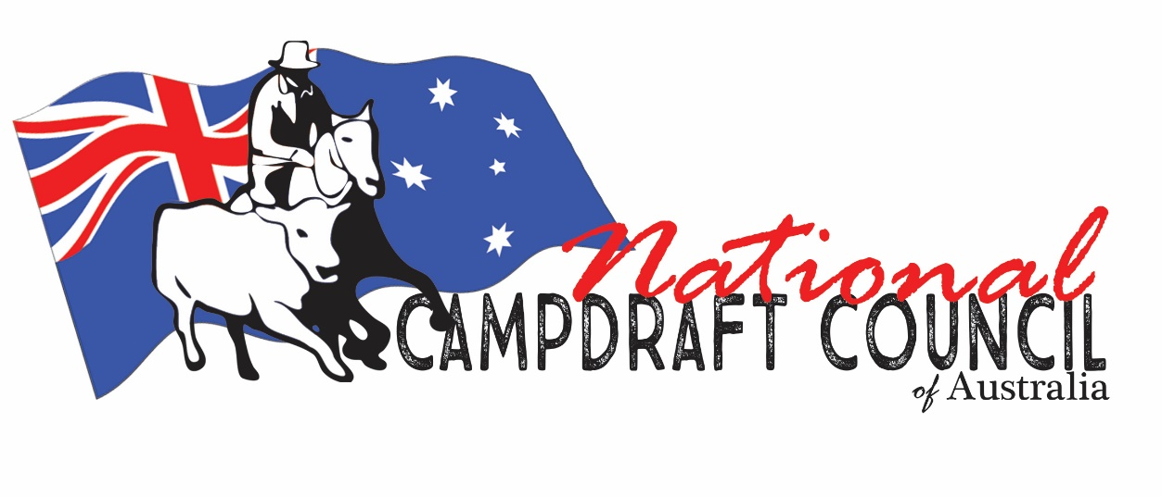 Pryde’s EasiFeed NCCA National Champion Rider Title Event

It was great to see our event take place amid Covid time. The PRYDE’S EasiFeed NCCA NATIONAL CHAMPION RIDER TITLE EVENT was held as part of the Nutrien Classic and it must be mentioned that the hard work they did to make this event happen was a fantastic effort.

Where else would you get to compete for part of a $25,000 Pryde’s EasiFeed cash and prize pool, as well as a Championship Belt Buckle and, a rug sponsored by the NCCA, a handcrafted bit from Rod Kaye Bits and Spurs, a service fee to Kniepps Conray donated by Yarrawa Park Stock Horses, and round trophy rugs sponsored by Campdraft Training Online for ZERO entry fee! All you must do is finish in the top 5 riders of your association and be the Champion Lady Rider for your Association.

The event was held at Tamworth again as part of the Nutrien Classic event. After a lot of hard work from the Nutrien Equine Team and Mark Barton the event was Covid safe allowing us to run. Thanks to all the Nutrien staff, Lachie Maxwell, and his team of yardmen, pencillers, side gate etc for all your hard work.

A HUGE THANK YOU to our cattle donors,
Round 1 Ellerston Pastoral Company
Round 2 Middlebrook Park - Tamworth NSW
Round 3 McGuire Family, Powerhouse Pastoral Company, Nundle NSW

As we all know without the generous support of cattle donors, our event would not be possible. Thanks also to Martin’s Stock Haulage for carting the cattle.

This year the event was run with the ABCRA supplying complimentary membership for our riders and using their system iCompete. Thank you to Craig Young and the Team of office girls from ABCRA being on hand during the event to score and run the program.

Our NCCA sponsor/competitor function was a great night, a great chance for all the riders, sponsors, and helpers to get together and the NCCA to thank their sponsors.

The event is staged over three rounds, with the highest total aggregate rider declared the winner. The top five riders and Champion Lady Rider from each of the four Campdrafting Associations in Australia being the Australian Campdrafting Association (ACA), Australian Bushman’s Campdrafting and Rodeo Association (ABCRA), Southern Campdrafting Association (SCA) and Gippsland Campdrafting Association (GCA) coming together to compete against one another for the title of Pryde’s Easifeed NCCA National Champion Rider.

Round 1 winner was Will Durkin from TEAM ACA Riding Hazelwood Conspiracy taking the win with an 89.5. Congratulations to Ben Hall riding Chisums Cash taking out the Round 2 and Round 3 win and the overall win after three rounds to take out the title of the Pryde's EasiFeed NCCA National Champion Rider Title. Ben won this event in 2005 riding Reliable and again in 2015 riding Foot Acre

This event was again made possible with the large and continued support of Pryde’s EasiFeed who donated cash and product to the value of $25,000 and all Associations join with the NCCA in thanking the Pryde’s family for their generous sponsorship. Pryde’s donated 160 bags of Easi Going, with each team member receiving 5 bags each. The winner of each round received 5 bags, the Judges received 5 bags each and the Overall Winner received 10 bags.

It was great to meet Hayley Elliott from Pryde’s this year who was there for the presentations. Pryde’s EasiFeed also sponsor 5 bags of feed to the person for the Judges Award. Our judges are selected by the NCCA at our AGM by the delegates from each Association. This year Simon Dodwell and Warwick Lawrence were selected and honoured to be chosen. They selected this year’s winner of the Judges Award to be Zac Svetlik from the GCA.

John Davison from Davo’s Whips donated a handcrafted 16 strand Kangaroo hide whip valued at $600 which this year was won by SCA rider Dalys Whipp for horsemanship. Davo has been a long-time supporter of this event and we thank him for his generous donation. The award recipient this year was selected by Codie Law and Davo’s son AJ was on hand to do the presentations.

Each team has an opportunity for their association to select a charity of their choice with $2,000 on offer to the winning team to donate.

Team GCA chose – Camp Quality, Team SCA chose Make a Wish Australia, Team ACA chose Dolly’s Dream and Team ABCRA chose Starlight Foundation.

The eventual Team win went to Team ACA. Well Done Team ACA and your charity Dolly’s Dream

A last shout out to the many wonderful helpers that made the task of running the event so much easier, Office Team ABCRA and the Nutrien Team for all your help with admin. Having Steve Condell on board to commentate is a huge plus as he brings so much energy, professionalism, and knowledge to the event.

Thanks everyone and Congrats to the winners and competitors that took part in the event for taking the time to travel to Tamworth. Look forward to seeing everyone again next year.

Team Totals
ACA – 1304
ABCRA – 955.5
GCA – 726.5
SCA – 688

2021 TEAMS

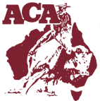
Team ACA
Ben Hall - Captain
Pete Comiskey
Steve Comiskey
Rohan Marks
Will Durkin
Bryony Puddicombe

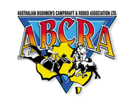
Team ABCRA
Bernie McMaugh – Captain
Jarrod Hannaford
Joseph Latham
Ben Tapp
Carolyn Burnes
Jessie Britton

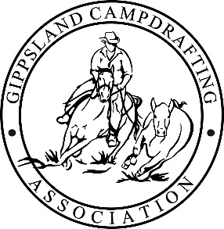

Team GCA
Mat Holz - Captain
Michael Hiscock
Zac Svetlik
Mark Ruff
Tanya Rand
Vicki Hiscock

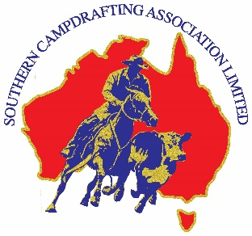

Team SCA
Nick Taylor - Captain
Ian Laurie
David Murphy
John Mitchell
Dalys Whipp
Paige Nancarrow

Winners and placegetters 1st – 8th Place

2022 Pryde's EasiFeed NCCA National Champion Rider results.

Round 1
Winner: Will Durkin riding Hazelwood Conspiracy
Round 2
Winner: Ben Hall riding Chisums Cash
Round 3
Winner: Ben Hall riding Chisums Cash

Final Placings after 3 rounds

1ST BEN HALL CHISUMS CASH 269
2ND WILL DURKIN HAZELWOOD CONSPIRACY 257.5
3RD ROHAN MARKS COWBOY 250
4TH STEVE COMISKEY KATIE 246.5
5TH JARROD HANNAFORD ELMO 234
6TH MICHAEL HISCOCK MEWBURN BEWICK 226.5
=7TH PETE COMISKEY HARRY 192.5
=7TH VICKI HISCOCK MEWBURN BAMALAM 192.5

