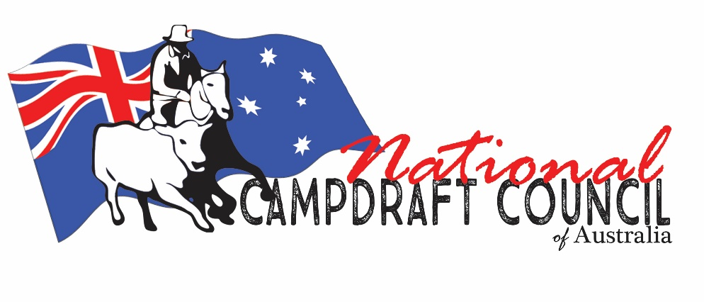
G u i d e l i n e s
__________________________________________
C A M P D R A F T L I G H T I N G &
Y A R D/ a r e n a D I M E N S I O NS

LIGHTING: 500 - 700 lux is the lighting level range we have seen achieve the best results; LED lighting can achieve this much easier than traditional lighting and also much lower power demand to operate. The other issue separate to the pure light rating is the height of the lighting towers. There will be a range of limiting factors including local geography, council planning requirements etc, but if lights of the magnitude to achieve that rating (500 lux) are too low it can inhibit visibility. 30 m towers have been able to avoid this, but local circumstances really do play a part in this.
If the future use of the venue may see either television or streaming at night, then a higher rating would be required; north of 1000 for perfect vision through the lens.
YARD/ARENA: All dimensions need to be relevant to the area and type of cattle you are drafting. Recommended min height for arena 1600 high fence. Camp 1.8 high fence min. Width 15-17 meters. 30-35 mtrs depth (including the taper at the front of the camp). Please also consult the association you affiliated with and local drafts in your area.

